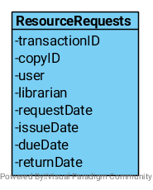
These operations run in the Copies class:
+returnCopy:
- Searches the table for all objects with copyID.
- Last record in the view set with an issueDate is selected.
- The return date is set to either today or a date passed as a parameter.
- If the view set has a “next record” (meaning there is a pending request), set the next record’s dueDate date.
- Return whether a fine is necessary.

+requestCopy:
- Search the table for all objects with copyID.
- If the last record in the view set has a returnDate set, create a new record and set the issueDate as today and dueDate as null.
- Else if the last record in the view set has an issueDate set and the requesting user is not the user in the last record, update their dueDate to the minimum length specified in duration.
- Create a new record for the current request.

+collectCopy:
- Search the table for all objects with copyID.
- If the dueDate has not passed and the requesting user is the correct one, set the issueDate as today.
- If the view set has a “next record” set the dueDate to the minimum duration.

+housekeeping: (This is run nightly to remove users that didn’t collect the copy.)
- Search the table for all objects with copyID.
- If the dueDate has expired and there is no issueDate, delete the record.
- Select the next record on from the deleted one and set the dueDate to the collection time.

Each class has it’s own table in the database. For example, the Resource class has a table which is referentially linked to the Book, Laptop and DVD tables using the resourceUID as foreign key.

